**LIST MATCHING DOCUMENTATION**

**Scripts**

hostInfoCompiler.ksh: generates 3 different reports that contain all the nodes’ information

* hardwareReport: contains name, date, os, kernel, model, cpu, zonetype
* softwareReport: contains Uptime software, NetBackup software
* zonelistReport: contains name, date, zonelist

listMatching.ksh: takes in list of nodes from each tool (BoKS, NetBackup, etc.) to generate a MasterTable (1)

listMatchingReports.ksh: generates 6 different reports:

* Yes_NA_Report.txt: A text file that contains the number of 'YES's and 'N/A's/total for each source with percentages, respectively.
* Extra_Hosts_Report.txt: A text file that contains all the lists of extra hosts from different sources.
* Expired_Exceptions_Report.txt: A text file that contains all the expired exceptions
* Exceptions_By_Date_Report.txt: A text file that contains all the exceptions sorted by date
* Exceptions_By_Hostname_Report.txt: A text file that contains all the exceptions sorted by host name
* Missing_Hosts_Report.txt: A text file that contains all the missing hosts that aren't in any sources but they are in the ExceptionFile (2)

mastertable2HTMLtable.ksh: using information from the Master (4) with no header and the MasterTable itself to convert MasterTable into MasterTable.html in order to be deployed on a web server.

extractnodes-for-listMatching.ksh: extract registered nodes out of a central administrative tool (NetBackup, BoKS, etc.) from each applicable node.

Example output: netbackup- psx02backup.list

extractnodes_syscheck-for-listMatching.ksh: similar to extractnodes-for-listMatching.ksh but only for Syscheck.

Example output: syscheck-psa03mgmt.list

catSources.ksh: concatenates all lists of produced by the extractnodes-for-listmatching.ksh from a respective tool into a final list of registered nodes for that tool.

Example output: NETBACKUP.list

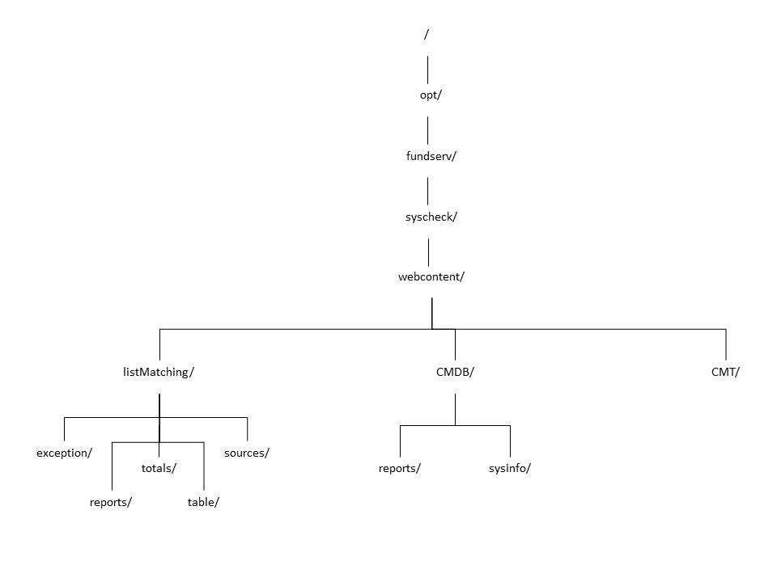**Folder Structure**

**Location of files**

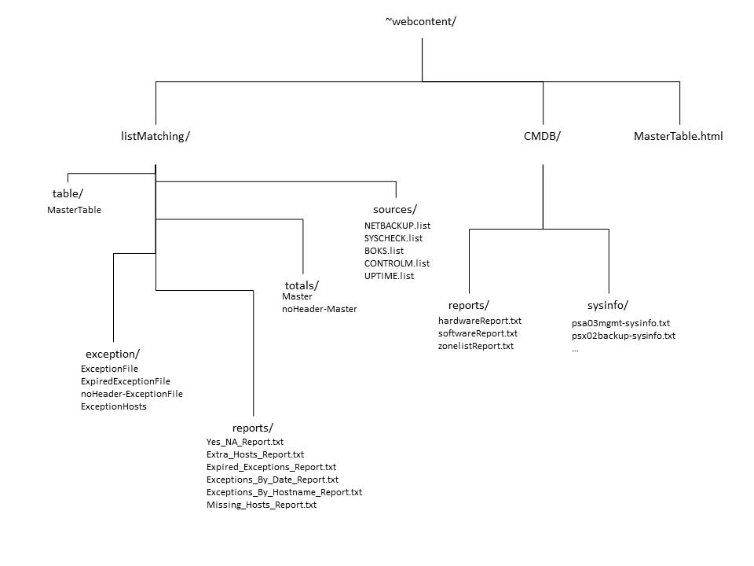*Since nothing is currently in CMT/, we’ll leave it out for now

**Procedures**

1. Collect all sources’ lists (besides Syscheck) of nodes (extractnodes-for-listMatching.ksh and catSources.ksh)
2. Collect list of nodes from Syscheck (extractnodes_syscheck-for-listMatching.ksh)
3. Generate a Master and a MasterTable (listMatching.ksh)
4. Generate 6 general reports (listMatchingReports.ksh)
5. Generate host-related reports (hostInfoCompiler.ksh)
6. Convert MasterTable to MasterTable.html (mastertable2HTMLtable.ksh)

**Terminology**

1. MasterTable: a table that contains all the nodes and which nodes exist in which tool (Uptime, BoKS, NetBackup, Syscheck, Control-M)

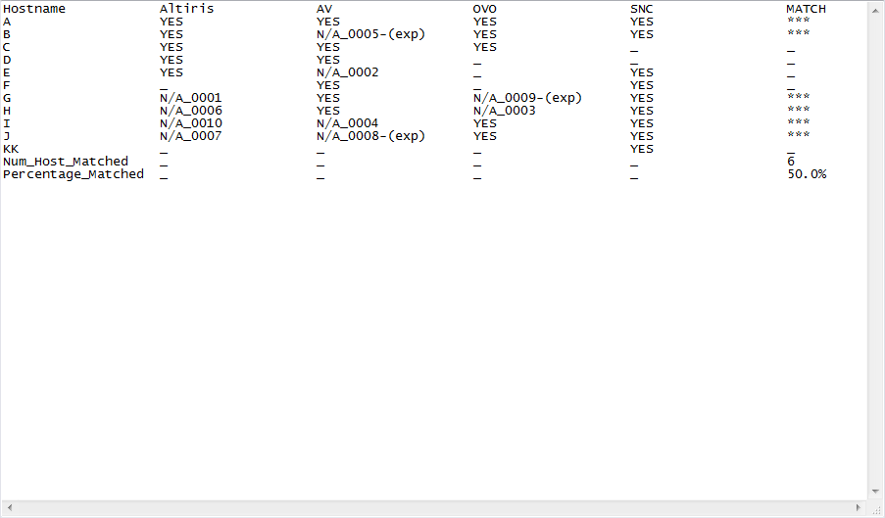Example:

1. ExceptionFile: a table that contains all the exceptions and their respective exception ids, tools (BoKS, NetBackup, etc.), nodes’ names, and expiration status.

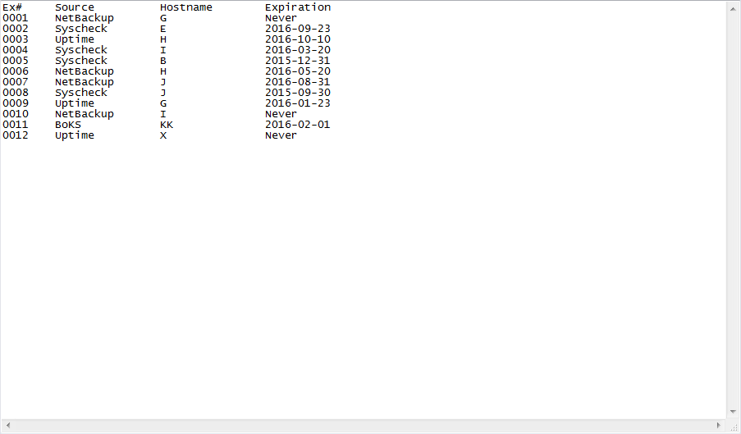Example:

1. Master

The first column of MasterTable that contains all the nodes registered in all the tools.

Example:

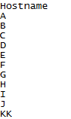

**Notes:**

PIKT wasn’t included in this list of tools since their it doesn’t have any central server to extract nodes from.